Dear Parents,
I’m excited to tell you about an upcoming AUTHOR VISIT. On _______________________, author Cathey Graham Nickell of Houston, Texas, will visit our school to speak to students in (insert grades).
Arthur Zarr’s Amazing Art Car is Cathey’s first children’s book. She draws from her experience as a former newspaper reporter and public relations professional to bring an upbeat presentation full of personal stories, writing/publishing tips, and “insider information” about her book.

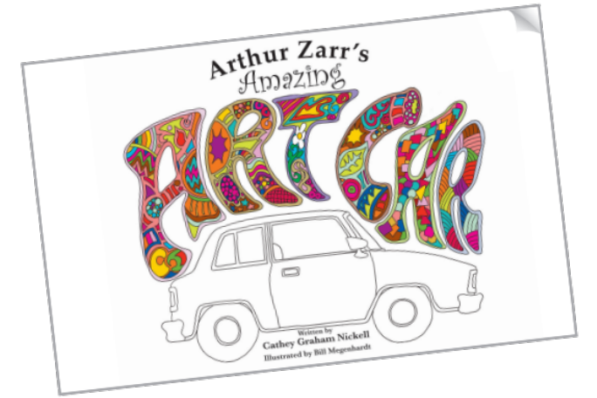
If you would like your child to have a book signed by the author, or if you want to order multiple books as gifts, please complete and return this form with payment to your child’s teacher. Cathey will sign and personalize each book. You are under no obligation to order a book, and Cathey will donate a copy to our school library.
Thank you!
[LIBRARIAN or TEACHER’S NAME & TITLE]
Questions: Please email xyz or call 123

“ARTHUR ZARR’S AMAZING ART CAR”
Written by Cathey Graham Nickell
Illustrated by Bill Megenhardt
SUMMARY: Arthur Zarr is a quiet man with few friends. His life is rather plain, and his car is plain, too. But not for long! Mr. Zarr finds happiness and makes friends by building an amazing art car. In this whimsical story, children learn about recycling, community, friendship building, and the power of imagination. The book includes a “History of Art Cars” page for readers who’ve never heard of this creative form of artistic expression. Children of all ages—and even adults—will enjoy the colorful story of Arthur Zarr. Hardcover book with dust jacket, 40 pgs, color illustrations. © 2016. MSRP $19.99 + tax. ISBN: 978-0-9961150-0-1
✂ - - - - - - - - - - - - - - - - - - - - - - - - - - - - - - - - - - - - - - - - - - - - - - - - - - - - - - - - - - - - - - - - - - - - - - - -
ARTHUR ZARR’S AMAZING ART CAR Book Order & Autograph Form
Book #1: Child’s Name (please print legibly!)_____________________________________________
□Check this box to verify that you want the book personalized by the author with your child’s name (above). If you prefer no personalization (signature only), please leave the box unchecked or make a notation to that effect.
Please list other name(s) below if you are ordering additional copies that you would like personalized:
Name(s) for Book #2: ________________________________________________________________
Name(s) for Book #3: ________________________________________________________________
Child’s Teacher & Grade______________________________________________________________
________ books @ $21.64 each (this price already includes the tax) = $_________________

Please make check or money order payable to Twenty-Eight Creative and return to your child’s teacher by [INSERT DATE]. Your child will receive his or her book(s) on the day of Cathey’s author visit to our school. Thank you for your support of this author! You may use the back of this page if more space is needed to order more than 3 copies of the book.

